HEART DISEASE ANALYSIS POWER BI PROJECT

PRINESH ROUT
DA DS

Project Description:
Heart Disease Dataset Analysis Using POWER BI

TABLE OF CONTENT

1.INTRODUCTION

Heart disease is one of the leading causes of mortality worldwide, making early analysis and identification of risk factors critically important. With the increasing availability of healthcare data, analytical tools play a vital role in transforming raw medical data into meaningful insights.
This project focuses on analyzing a heart disease dataset containing patient demographic and clinical attributes such as age, gender, chest pain type, cholesterol levels, blood pressure, and heart rate. Using Power BI, the data is cleaned, transformed, and modeled to ensure accuracy and consistency. Interactive dashboards and visualizations are developed to identify patterns, trends, and key indicators associated with heart disease, supporting data-driven healthcare analysis and decision-making.

2. AIM OF THE PROJECT

The aim of this project is to analyze a heart disease dataset using Power BI to understand the impact of demographic and clinical factors on heart disease occurrence. By performing data cleaning, transformation, and visualization, the project seeks to identify patterns, trends, and risk indicators related to heart disease. The ultimate goal is to present these insights through interactive dashboards that support clear, data-driven analysis in a healthcare context.

3.PROBLEM STATEMENT

Heart disease remains a major health concern, and understanding the factors that contribute to its occurrence is essential for effective analysis and decision-making. However, raw healthcare data is often complex, unstructured, and difficult to interpret without proper processing and visualization. There is a need for an interactive and analytical approach to explore patient demographic and clinical data to identify key patterns and risk factors associated with heart disease. This project addresses this challenge by using Power BI to transform and visualize heart disease data for meaningful insights.

4.PROJECT WORKFLOW

- DataCollection
The heart disease dataset was collected from Kaggle, containing patient demographic and clinical information.
- DataLoading
The dataset was imported into Power BI for analysis.
- Data Cleaning & Preprocessing
Missing values, duplicates, and inconsistencies were handled using Power Query, and data types were corrected for accuracy.
- Data Transformation & Modeling
New columns and DAX measures were created to support analytical requirements.
- Visualization Development
Interactive dashboards were designed using appropriate charts, KPI cards, and slicers.
- Insight Generation
Key patterns, trends, and risk factors related to heart disease were identified.
- Conclusion & Reporting
Final insights were summarized to support data-driven understanding and presentation.
5. DATA UNDERSTANDING

The heart disease dataset consists of patient demographic and clinical attributes used to analyze the presence of heart disease. Key variables include age, gender, chest pain type, blood pressure, cholesterol level, heart rate, and exercise-related indicators. The target variable represents whether a patient has heart disease or not. Initial data exploration was performed to understand the structure, data types, and value distributions, which helped identify missing values, inconsistencies, and relevant features for further analysis.

6. DATA CLEANING

Data cleaning was performed using Power Query to ensure accuracy and consistency. This included removing duplicate records, handling missing values, correcting data types, validating categorical variables, and eliminating invalid or inconsistent entries. These steps prepared the dataset for reliable analysis and visualization in Power B

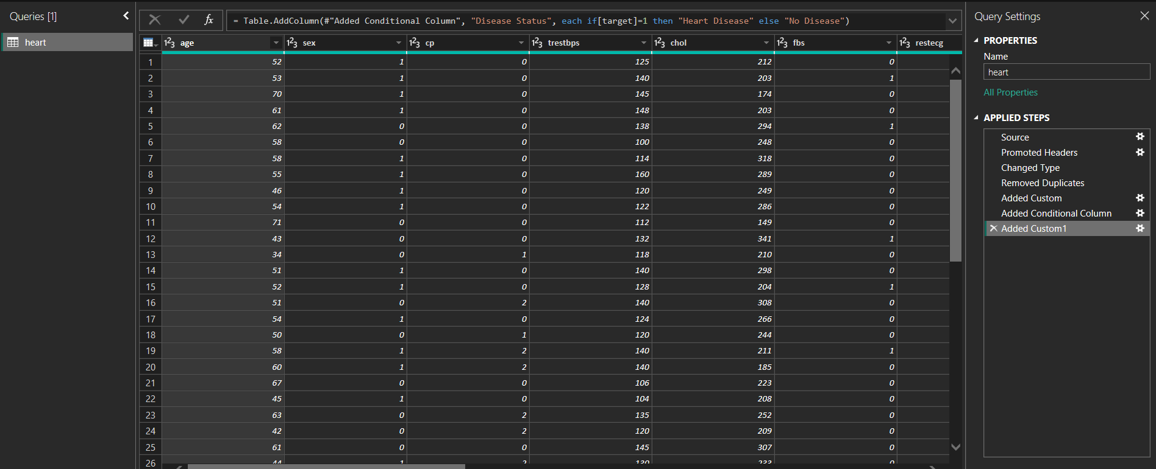

7.FILTERING DATA FOR ANALYSIS

Relevant data was filtered using slicers and visual-level filters in Power BI to focus on specific patient groups based on age, gender, chest pain type, and risk indicators. This filtering enabled targeted analysis, reduced noise, and improved the clarity and accuracy of insights derived from the dataset.
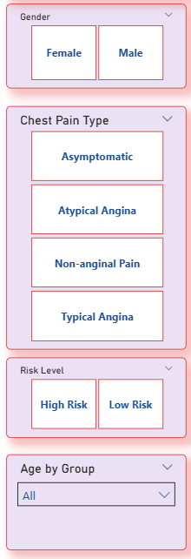

- KEY MATRICS CALCULATIONS
Key performance metrics were calculated using DAX to support effective analysis. These include total patients, heart disease patients, non-disease patients, disease percentage, average age, average cholesterol level, and high-risk patient count. These metrics enable quantitative evaluation of heart disease patterns and support data-driven insights in the dashboard.
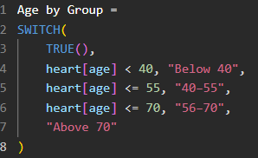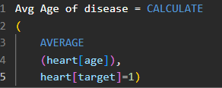

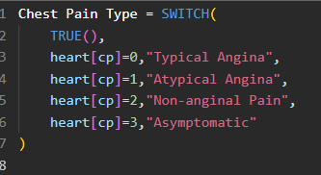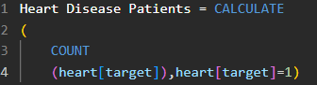

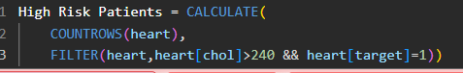
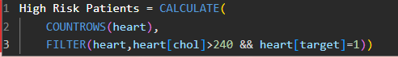
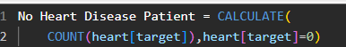
- DASHBOARD OVERVIEW

The Power BI dashboard presents an interactive view of heart disease analysis through key metrics, comparative charts, and trend visualizations. KPI cards summarize patient counts and disease prevalence, while charts analyze patterns across age, gender, and clinical factors. Slicers enable dynamic filtering, allowing users to explore insights and identify heart disease risk factors efficiently.

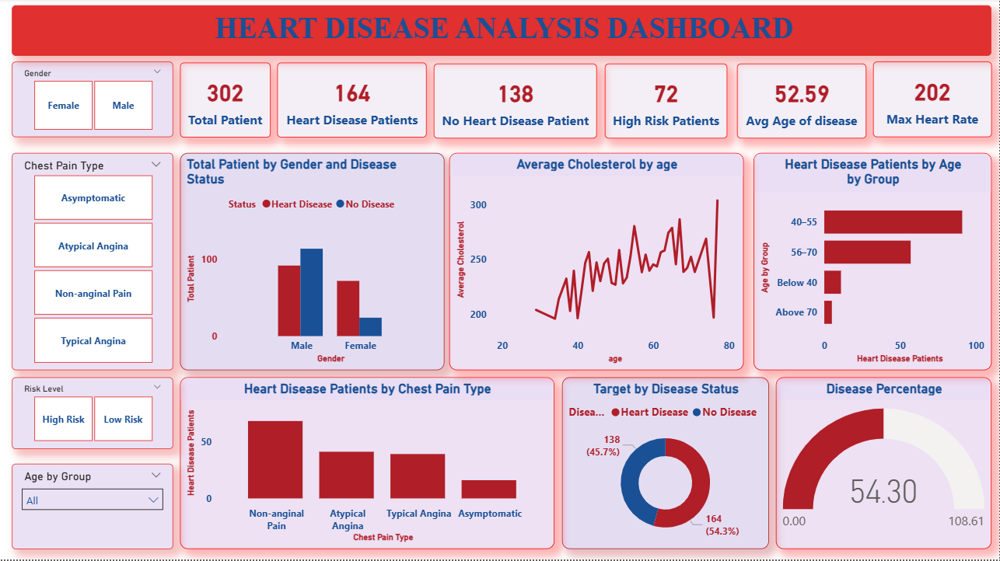
10.RESEARCHED INSIGHTS
- Total Patients :302 whereas number of heart disease patients:164(~54.3%)
- No heart disease patient found(~45.7%) which indicates half of the patients are affected indicating a high prevalence of heart disease in the dataset.
- Males show significantly higher heart disease cases compared to females whereas females show lower proportion of heart disease which indicates Gender is a strong risk factor ,with males being more vulnerable.
- Nonanginal pain has the highest number of heart disease patients & Atypical angina & typical angina show moderate cases & Asymptomatic patients still show presence of heart disease that means heart disease can exist even without classic chest pain making diagnosis tricky.
- Age group 56&70 has the highest heart disease cases & 40to55 age group is the second most affected which defines Risk increases with age especially after mid-40s.
- Average cholesterol fluctuates with age & Peaks are visible around middle & older age groups indicates Cholesterol instability in later ages may contribute to higher heart disease risk.
- Highrisk patients : 72 shows a considerable number of patients require immediate medical attention or monitoring.
- Maximum heart rate recorded : 202 indicates extremely high heart rate values may indicate cardiac stress during exertion.

11.RECOMMENDATION

- Conduct regular cardiac screenings for individuals above 45 years & promote preventive checkups for middle-aged & elderly populations.
- Introduce targeted awareness programs for men focusing on lifestyle risks.
- Encourage early testing even when symptoms are mild.
- Doctors should not rely only on classic chest pain symptoms.
- Use ECG, Stress tests & Cholesterol analysis for early detection.
- Regular lipid profile tests for patients above 40.
- Promote diet control & meditation adherence for high cholesterol patients.
- Prioritize high risk patients for immediate intervention.
- Implement continuous monitoring systems for the high- risk patient individuals.
- Advise patients to follow medically supervised exercise plans & avoid intense workouts without prior cardiac evaluation.
- High disease percentage(54.3%) suggests a serious public health concern so Government & healthcare bodies should invest in early screening programs.
- Promote heart-health education campaign at community level.

12.CONCLUSION
- This project successfully demonstrates the application of Power BI in analyzing healthcare data related to heart disease. By performing systematic data cleaning, preprocessing, and transformation, the dataset was prepared for accurate and reliable analysis. The use of DAX-based metrics and interactive visualizations enabled the identification of key demographic and clinical factors influencing heart disease occurrence.
- The developed dashboard provides a comprehensive and intuitive view of heart disease patterns across different patient groups, supporting effective exploration and interpretation of data. Overall, the project highlights the value of business intelligence tools in transforming raw medical data into actionable insights and supports data-driven analysis in the healthcare domain.

- Furthermore, this analysis emphasizes the importance of data visualization in simplifying complex healthcare data and enhancing analytical clarity. The interactive nature of the Power BI dashboard allows users to explore data from multiple perspectives, making it a valuable tool for understanding trends, supporting informed decision-making, and strengthening analytical skills in real-world healthcare applications.

